This project has received funding from the European Union's Horizon Europe research and innovation programme's HORIZON-INFRA-2023-TECH-01 call under Grant Agreement No. 101131516
Milestone
M5 Production of waste water at 50°C by high field magnets

Project Milestone Information Sheet
FlexRICAN Project | Project Ref. No. 101131516
FlexRICAN Project | Project Title: FlexRICAN – Flexibility in RIs for global CArbon Neutrality
FlexRICAN Project | Project Website: www.FlexRICAN.eu
FlexRICAN Project | Work Package: WP 5
FlexRICAN Project | Milestone: M5 Production of waste water at 50°C by high field magnets

Document Control Sheet
Document | Title: M5 Production of waste water at 50°C by high field magnets
Document | Version: v.20250714
Document | Available at: N/A
Document | Files: 1
Authorship | Written by | François Debray and Uli Zeitler
Authorship | Contributors | Femke Bangma and Frans Wijnen
Authorship | Reviewed by | Discussed in WP5 meeting 10th July 2025
Authorship | Approved | FlexRICAN Steering Board

List of Abbreviations and Acronyms
AL | Alfa Laval
ATES | Aquifer Thermal Energy Storage
CNRS | Centre national de la recherche scientifique
ELI | The Extreme Light Infrastructure ERIC
EMFL | European Magnetic Field Laboratory
EP | Energy Pool
ESRF | European Synchrotron Radiation Facility
ESS | European Spallation Source ERIC
EU | European Union
GA | General Assembly
HFML | High Field Magnet Laboratory
HZDR | Helmholtz-Zentrum Dresden-Rossendorf
LCA | Life Cycle Assessment
LCNMI | Le Laboratoire National des Champs Magnétiques Intenses
MW | Megawatt
RA | Radboud University
RI | Research Infrastructure
SB | Steering Board
WP | Work Package

Milestone 5: Production of outlet water at 50°C by high field magnets
The original idea of establishing this milestone was to investigate if the outlet temperature at the DC magnets could be increased to 50°C so that this waste heat could be used, either directly or indirectly, for a district or a local heating network.

We have now shown that indeed a water outlet temperature above 45°C can be produced in the two European DC high field facilities of the EMFL (HFML Nijmegen and LNCMI Grenoble), (see Fig. 1 and Fig. 2 for two recent typical high-power experiments.

HMFL-Nijmegen State of the Art
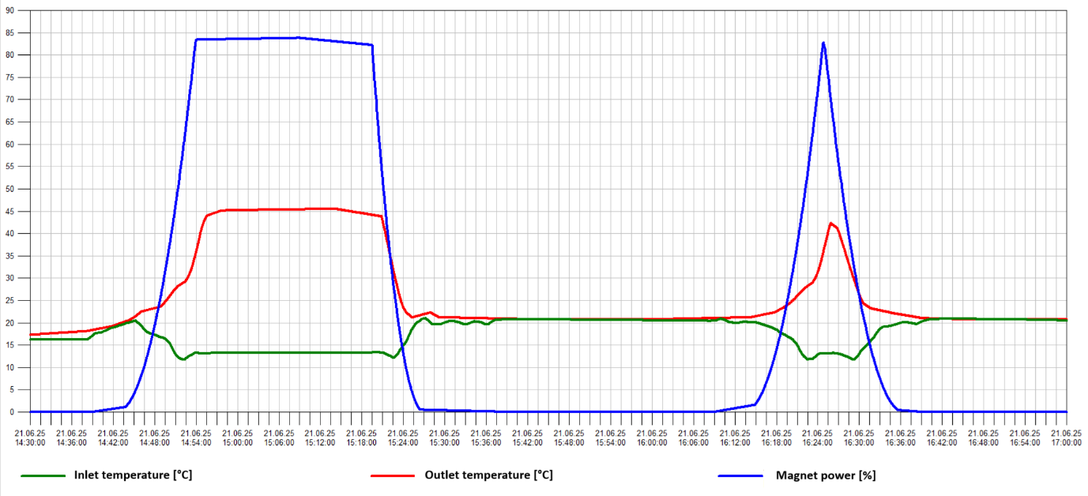
Fig. 1: Magnet water outlet temperature at high power at the Nijmegen high field facility on the 21st of June 2025. For this experiment cell 1 was powered with 18 MW (30 T) at a water flow of 140 l/s. The magnet inlet temperature was 15°C.

Technically, the magnet outlet temperature for cell 1 at HFML Nijmegen (Fig. 1) could be straightforwardly increased to above 50°C by either increasing the inlet temperature to 20°C or reducing the water flow to 120 l/s.

In this respect, the milestone “Production of outlet water at 50°C by high field magnets” has been (nearly) reached.

LNCMI-Grenoble State of the Art
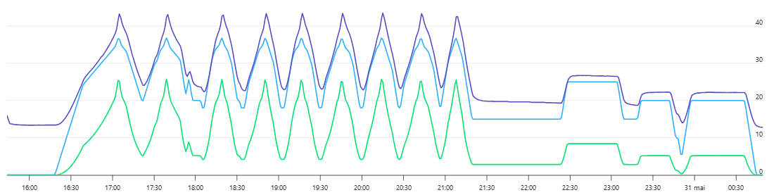
Fig. 2: High field experiment at LNCMI-Grenoble on the 30th of May 2025.
Dark Blue: Outlet Temp (Max 43.4°C) Light Blue: Magnetic Field (maximum 37 T), Green: electrical power (maximum 25.5 MW). The scale on the right is common to the three parameters. A variable flowrate is set (90 to 255 l/s).

Similar data can be obtained for LNCMI-Grenoble (Fig. 2) with a water outlet temperature in excess of 40°C but only when using the installation at high electrical power. Obviously, the same consideration also holds for HFML-Nijmegen.

Output of the milestone
For both installations, outlet temperatures in excess of 40°C could be produced on larger time scales and a larger range of power by optimising or developing variable cooling rates on the primary and/or the secondary cooling loop of each process.

However, the following risks were identified during this work which make these solutions less attractive:
- A higher average magnet temperature will reduce the life time of the coils by adding thermal constraints to the magnetic pressure
- The power consumption of the coils will increase due to the larger electrical resistance of copper at higher temperatures (~ 1% of extra power for each 3°C).
Therefore, as stated in our milestone prolongation request to the EU (Feb. 2025), 50°C on the magnet outlet would be energetically unfavourable for an optimal magnet performance and could ruin the Life Cycle Assessment (LCA) of the high field magnets considering heating services (see also D.7.3 due in month 35).

Additionally, on the two high field facilities the magnet outlet temperature averaged over several hours at an average power of 6 MW only amounts to ~25°C.
Therefore, while outlet temperatures in the range 40° to 50°C are technically reachable, it will be not efficient to rely on this number for long-term heating applications.

Conclusion
The work for the establishment of this milestone has modified our reasoning on heat recovery development. The present milestone was at the beginning based on the question “what is required from outside the RIs?” (namely 50°C water for district or local heating applications). In the FlexRICAN project we are now moving to a more global view which considers the RIs and the heating districts managers as stakeholders of a common project.

Therefore, it implies to develop parametric studies on outlet temperature to study the global Life Cycle Assessment of the heat valorisation process. The open access Software OMEGAlpes is now used in the project for this purpose.

OMEGAlpes Energetic Notebooks developed to prepare D.6. 1 (due month 35) are including the specific environment of each RI. Consequently, they will be a valuable tool to contribute to develop the global approach by integrating in the energetical model:
- the aquifer thermal energy storage (ATES) in operation in Nijmegen,
- the potential development of an interseasonal storage in Grenoble in collaboration with the ESRF and the city district.
Systems such as these typically only require water temperatures of ~25°C, which is then the heat source for heat pumps that warm buildings. RIs often can easily access this temperature level and provide vast quantities of valuable heat. Indeed, this has been shown in Nijmegen with the ATES that heats the university buildings.

This way RIs can offer an important example in sustainability, which stimulates industry, such as data centers, to follow suit. Our FlexRICAN partner Alfa Laval has, in parallel, proven this very same point, see, e.g
https://sustainability.fb.com/wp-content/uploads/2020/12/FB_Denmark-Data-Center-to-Warm-Local-Community.pdf.
As such, this is already on its own an important outcome of the FlexRICAN project and our investigations to establish milestone 5.

